Project #1 Title - Cost-Optimized Event-Driven Serverless Data Processing Platform on AWS

Overview
This project demonstrates the design and implementation of a serverless, event-driven data processing system on AWS. Traditional server-based architectures were replaced with a fully managed serverless approach to achieve:
- Reduced infrastructure cost
- Improved scalability
- High availability
- Asynchronous processing
The system processes files uploaded to storage automatically without manual intervention.

Objectives
- Reduce operational and infrastructure costs
- Build a scalable and highly available system
- Decouple system components using messaging
- Enable asynchronous file processing
- Provide real-time notifications

Architecture Summary
The solution follows an event-driven architecture using AWS managed services.
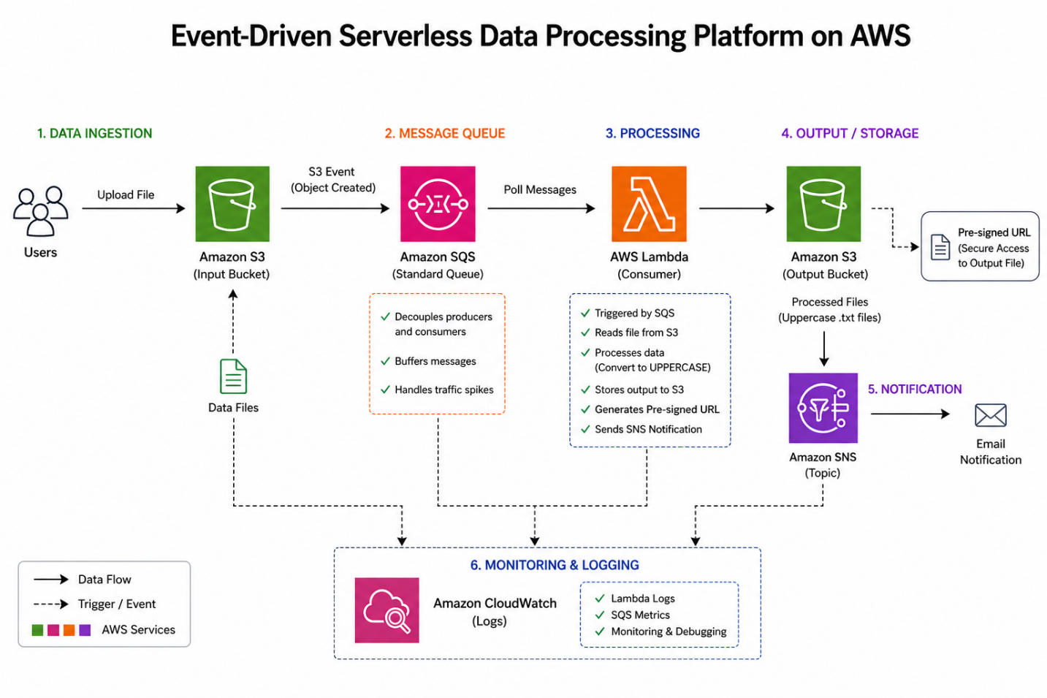

Key Components:
- Input storage for file uploads
- Message queue for decoupling
- Serverless compute for processing
- Output storage for processed data
- Notification service for alerts
- Monitoring and logging system

Architecture Flow
- User uploads a file to the input S3 bucket
- S3 triggers an event notification to SQS
- SQS stores the message and decouples components
- Lambda function is triggered by SQS
- Lambda reads the file from S3
- Data is processed (converted to uppercase)
- Processed file is stored in the output S3 bucket
- A pre-signed URL is generated for secure access
- SNS sends an email notification with the file link
- CloudWatch logs all activities for monitoring

AWS Services Used
Service | Purpose
Amazon S3 | File storage (input & output)
Amazon SQS | Message queue for decoupling
AWS Lambda | Serverless compute for processing
Amazon SNS | Email notifications
Amazon CloudWatch | Logs and monitoring
AWS IAM | Access control and security

Implementation Steps

Step 1: Create S3 Buckets
- Got to AWS Console -> S3 -> Create Bucket
- Input Bucket name: input-bucket-singapore (must be unique)
- Input Bucket name: output-bucket-singapore1 (Same Region)
- Region: ap-south-1 (Mumbai)
- Block all public access: ✅ ON (keep default)
- Versioning: Optional (enable if you want)
- Click - Create Bucket

Step 2: Configure SQS
- Create a queue
- Type: Standard Queue, Name - data-queue
- Visibility timeout: 30 sec (default is fine)
- Message retention: default
- Click - Create Queue

Step 3: Create Lambda Function
- IAM → Roles → Create Role
- Trusted entity: AWS Service
- Use case: Lambda
- Attach policies: AmazonS3FullAccess, AmazonSQSFullAccess , CloudWatchLogsFullAccess, AmazonSNSFullAccess
- Name role: lambda-s3-sqs-role
- Create Role

Step 4: Create Lambda Function
- Lambda -> Create Function
- Author from scratch
- Function name: data-processor
- Runtime: Python 3.12
- Execution role: Use existing role
- select lambda-s3-sqs-role - Create Function

Step 5: Develop Lambda Code
CODE :
import json
import boto3
import urllib.parse
import time

s3 = boto3.client('s3')
sns = boto3.client('sns')

def lambda_handler(event, context):
for record in event['Records']:

# Step 1: Get SQS message body
body = json.loads(record['body'])

# Step 2: Get S3 event
s3_event = body['Records'][0]

bucket_name = s3_event['s3']['bucket']['name']
object_key = urllib.parse.unquote_plus(s3_event['s3']['object']['key'])

print("Bucket:", bucket_name)
print("File:", object_key)

# Step 3: Read file from S3
response = s3.get_object(Bucket=bucket_name, Key=object_key)
file_content = response['Body'].read().decode('utf-8')

print("Original Content:", file_content)

# Step 4: Process
processed_data = file_content.upper()

print("Processing done, going to save file...")
print("Saving to output bucket...")

# Step 5: Create unique output key
filename = object_key.split('/')[-1].replace('.txt', '')
output_key = f'output-{filename}-{int(time.time())}.txt'
# Step 6: Save to output bucket
s3.put_object(
Bucket='output-bucket-singapore1',
Key=output_key,
Body=processed_data,
ContentType='text/plain'
)

print("Saved file:", output_key)

# Step 7: Generate Pre-Signed URL
url = s3.generate_presigned_url(
'get_object',
Params={'Bucket': 'output-bucket-singapore1', 'Key': output_key},
ExpiresIn=3600
)

print("Pre-Signed URL:", url)

# Step 8: Send SNS Email
sns.publish(
TopicArn='arn:aws:sns:ap-southeast-1:543687745943:output-alert',
Message=f'File ready: {url}',
Subject='S3 Output Ready'
)

return {
'statusCode': 200,
'body': 'Processing Done'
}

-> Deploy this code.

Step 6: Connect SQS - Lambda Trigger
- Inside Lambda -> Go to Triggers
- Click Add Trigger
- Select SQS
- Choose queue:data-queue
- Add trigger

Step 7: Connect S3 - SQS (Event Trigger)
- S3 → Input bucket → Properties
- Event Notifications → Create event
- Name: s3-to-sqs
- Event type: PUT (Object Created)
- Destination: SQS Queue
- Select: data-queue
- Save changes

Step 6: Create SNS Topics & Configure S3 Event
- Create SNS Topics - Type-Standard
- Name - ‘alert-topic’ -> create
- Click Create subscription - Protocol: Email
- Endpoint: your email id - Create subscription
- S3 → open your output bucket
- Properties->Event Notifications->Create event notification
- Name: output-alert -> Event types:Object Created (PUT)
- Destination:SNS topic -> Choose:alert-topic -> save
Step 7: Enable Monitoring
- CloudWatch → Logs → Lambda log group
- Track execution and errors
Step 8: Test Flow
- Go to input S3 bucket -> Upload a file: this is a cloud project…
- Flow will happen automatically : S3 → SQS → Lambda → S3 Output-> SNS alert
- Check output bucket : Here see the output-txt.txt
- We will see the output: THIS IS A CLOUD PROJECT

Key Features Implemented
- Event-driven architecture
- Serverless processing (no servers)
- Automatic scaling
- Asynchronous workflow
- Secure file access using pre-signed URLs
- Real-time email notifications
- Fault tolerance with retry capability

Security Implementation
- IAM roles with least privilege access
- Secure S3 access (no public exposure)
- Temporary access using pre-signed URLs
- Controlled SNS publishing

Monitoring & Logging
- CloudWatch logs for Lambda execution
- Debugging using log streams
- Tracking file processing status
- Identifying and fixing runtime issues

Cost Optimization
- Eliminated EC2 instances
- Used pay-per-use Lambda model
- Leveraged managed AWS services
- Optional S3 lifecycle policies for storage optimization

Challenges & Fixes

Issue 1: Duplicate email notifications
- Cause: Multiple SNS triggers
- Fix: Centralized SNS in Lambda

Issue 2: Output file downloading instead of opening
- Cause: Missing Content-Type
- Fix: Added ContentType='text/plain'

Issue 3: Incorrect pre-signed URL
- Cause: Wrong object key format
- Fix: Cleaned filename logic

Issue 4: Lambda execution failure
- Cause: Indentation errors in code
- Fix: Corrected Python structure

Issue 5: Debugging difficulty
- Solution: Used CloudWatch logs effectively

Outcome & Impact
- Reduced infrastructure cost by ~60–80%
- Achieved automatic scalability
- Improved system reliability
- Reduced manual effort
- Enabled real-time processing and alerts

Conclusion
This project successfully demonstrates how to build a modern, scalable, and cost-efficient serverless data processing system using AWS services. It highlights key cloud concepts such as:
- Event-driven architecture ,
- Serverless computing
- Decoupled system design
- Monitoring and debugging
Screenshot:

